5. List Manipulation

Table of Contents

|  |  |  |
| --- | --- | --- |
| Sl. No | Topics | Page No |
| 5.1 | **List Manipulation** | **2** |

## 5.1 List Manipulation

**What is List?**

List is the most versatile datatype available in Python, which can be written as a list of comma-separated values (items) between square brackets

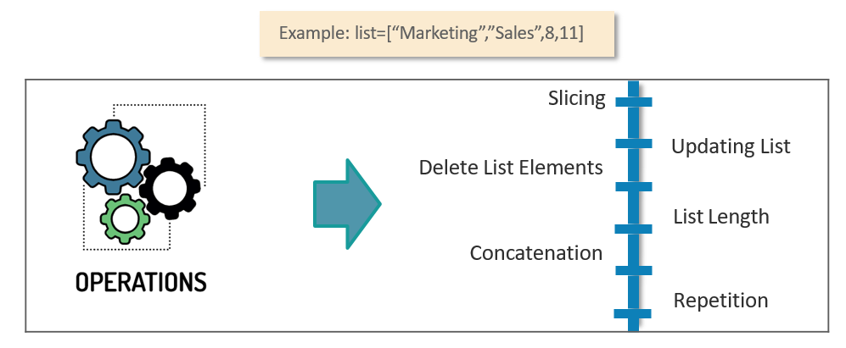

**When to use Lists?**

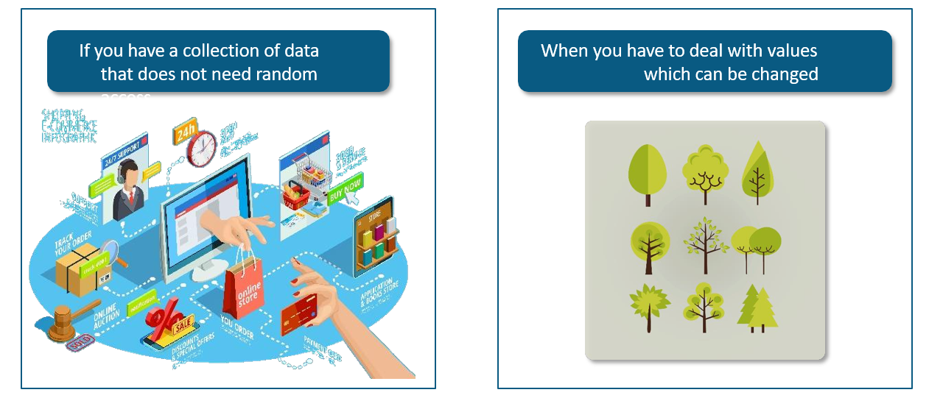

**Lists – Indexing and Slicing**

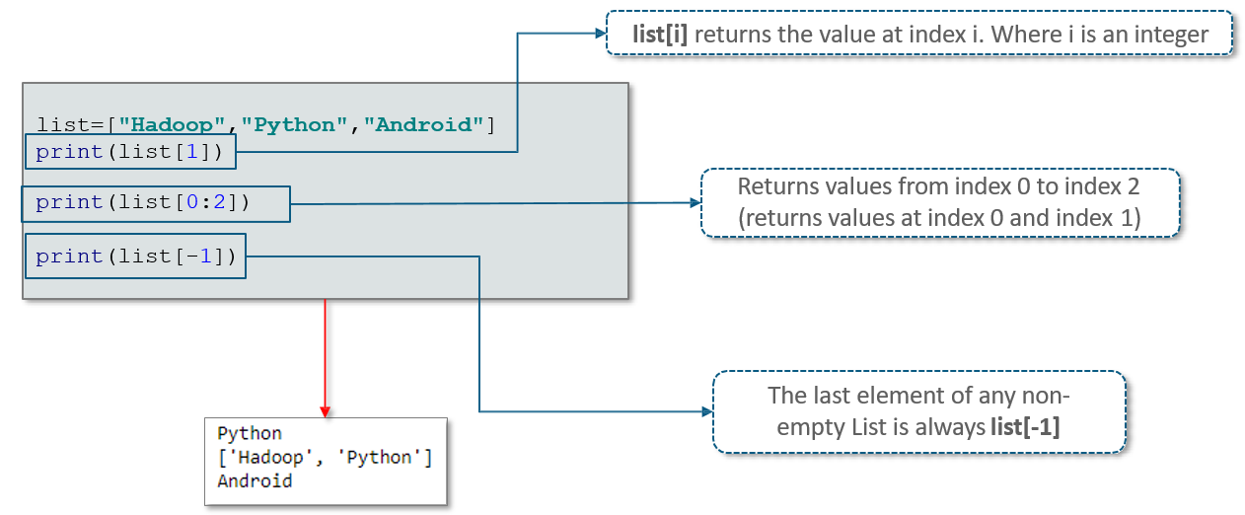

**Lists - Updating and Deleting Elements**

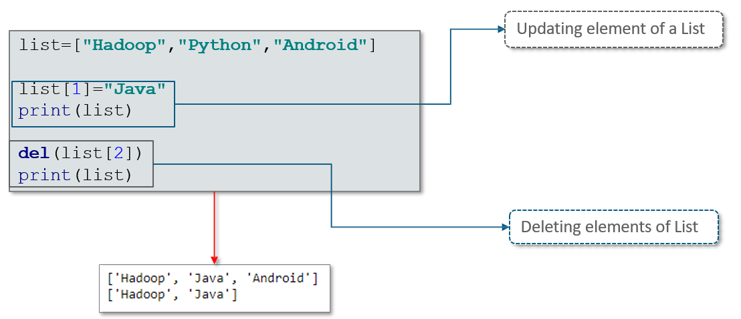

**Lists – Remove and Pop Functions**

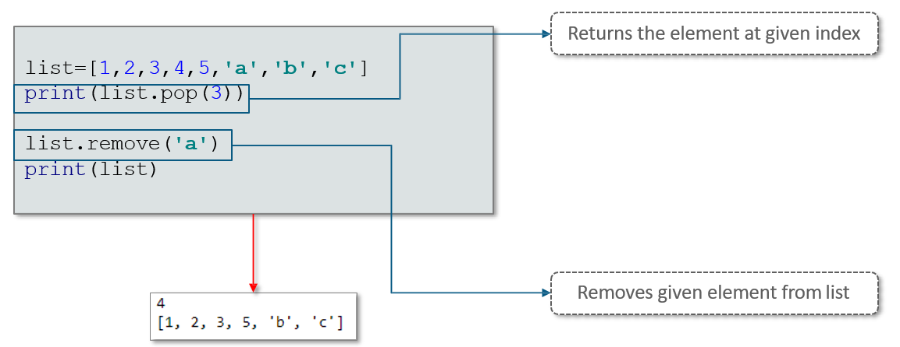

**Lists – type()**

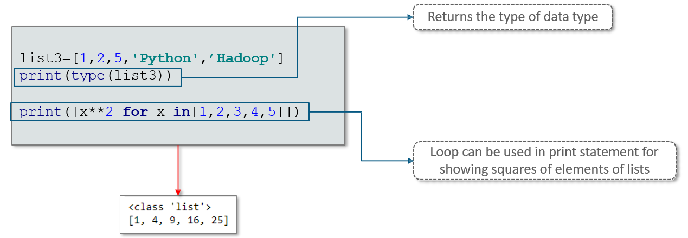

**Lists – Built In Functions**

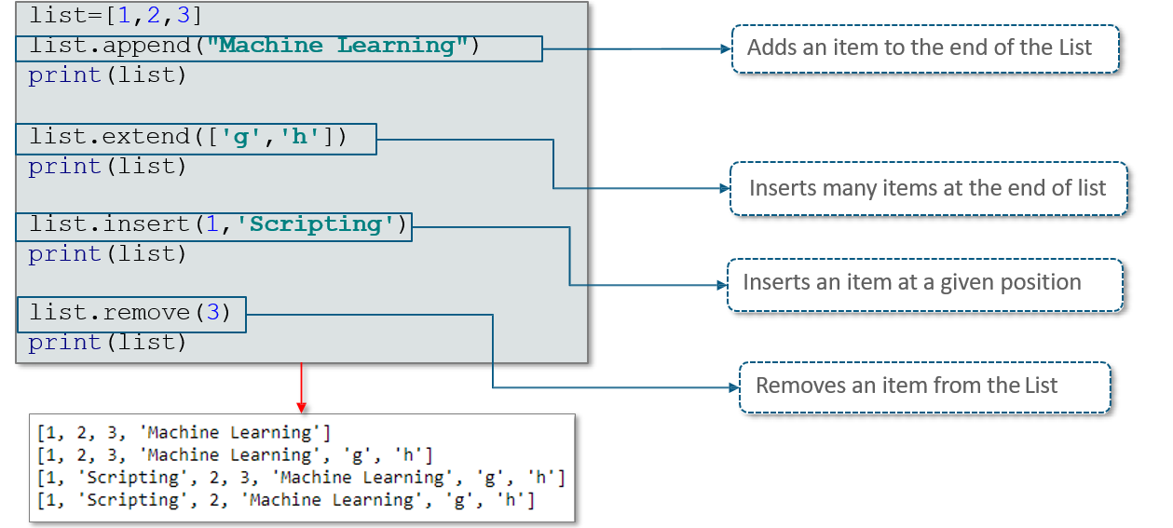

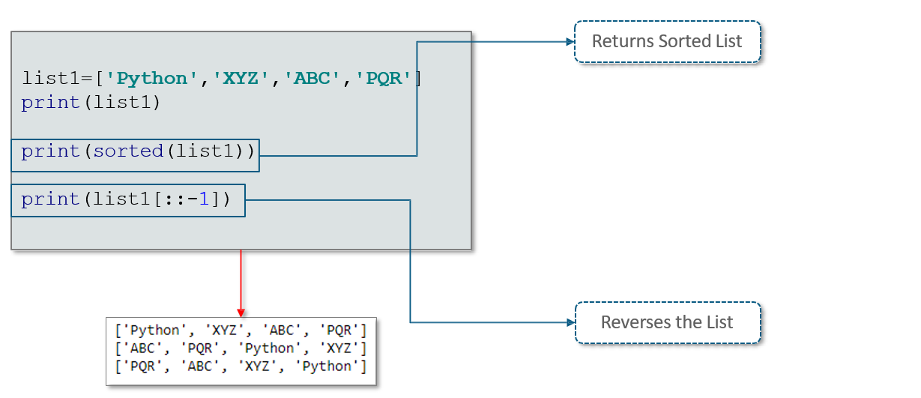

**A Tuple inside a List**



